Depiction of Issue: Section H of your RR Budget form does not provide an Indirect Cost Type selection:

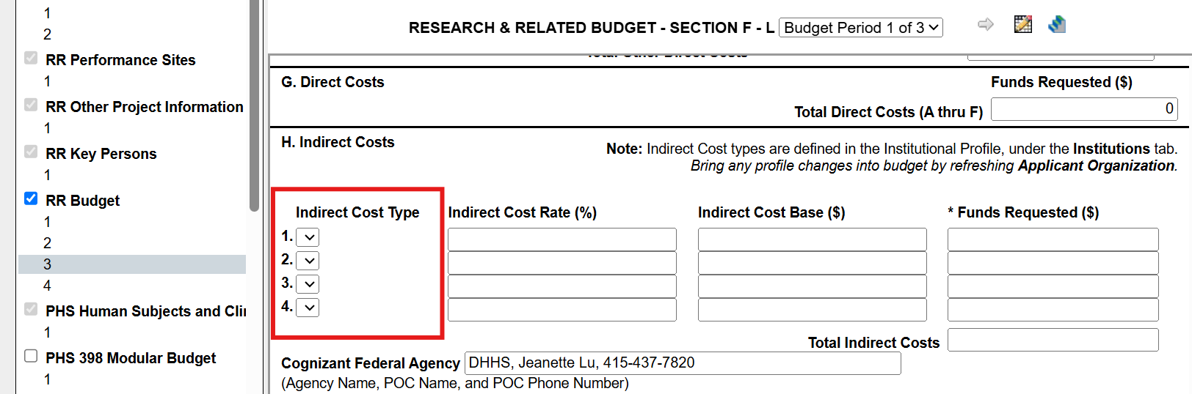

Here are steps:
Disclaimer: **Please be aware**: the other direct cost description fields in Section F (in red box below) will need to be re-entered after re-autofilling the Applicant Organization information. We recommend taking screenshots of this section in ALL budget periods to capture this information before proceeding.
- Re-autofill Applicant Organization: green icon (highlighted in screenshot below)
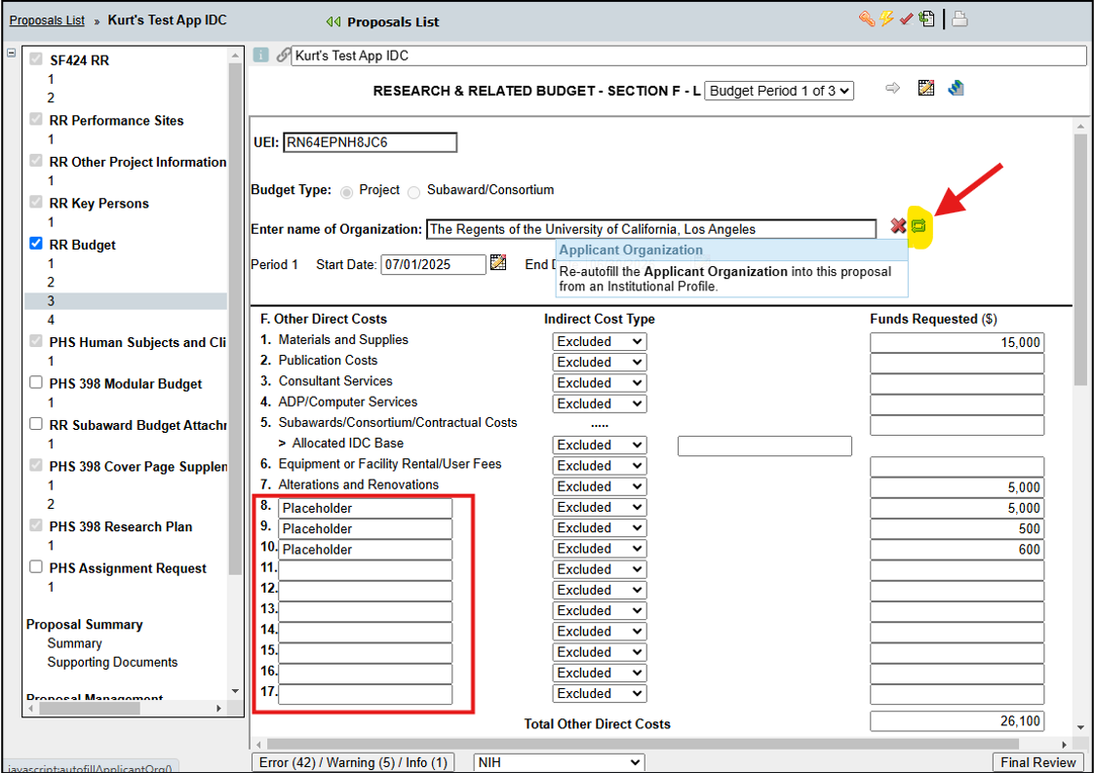
- Once you have selected to Re-autofill the Applicant Organization, you will see the below pop-up. Select the IDC rate from the drop-down and select the “Re-autofill Applicant Organization” button:

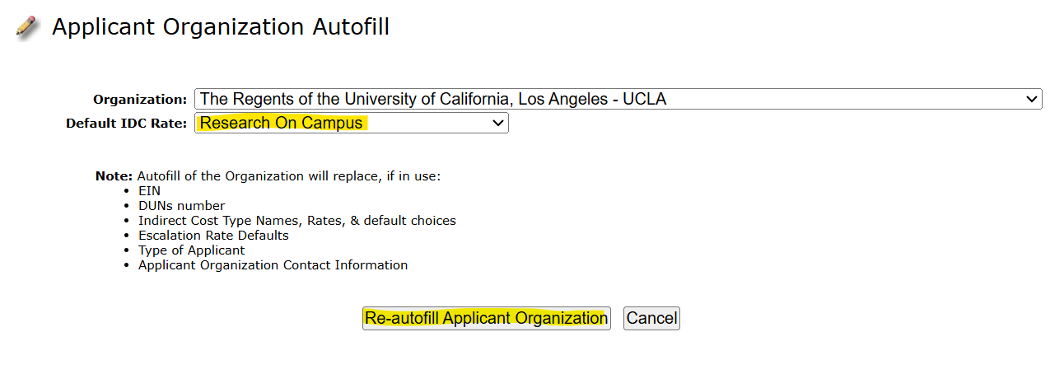

- Update IDC type drop-down selections in ALL budget periods:
The Indirect Cost Type drop-downs will need to be manually updated from “Excluded” to your selected IDC type in the following sections for EACH budget period:
Section B: Other Personnel - salary and fringe
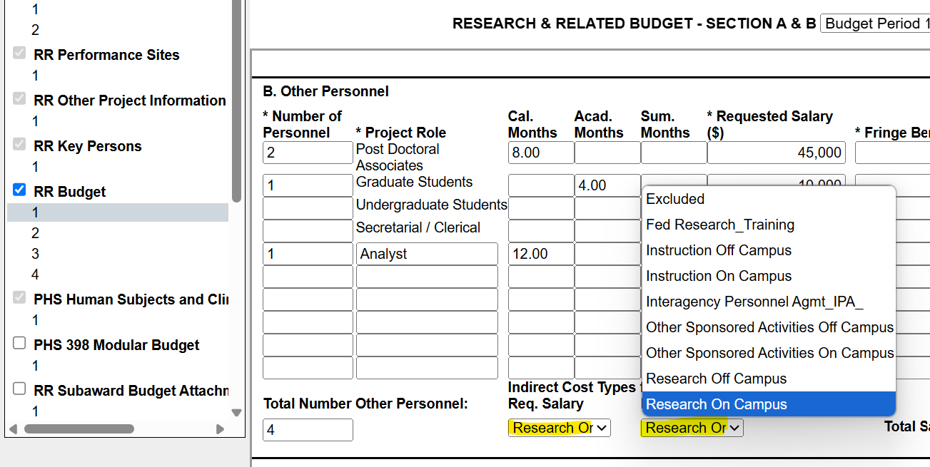

Section D: Travel
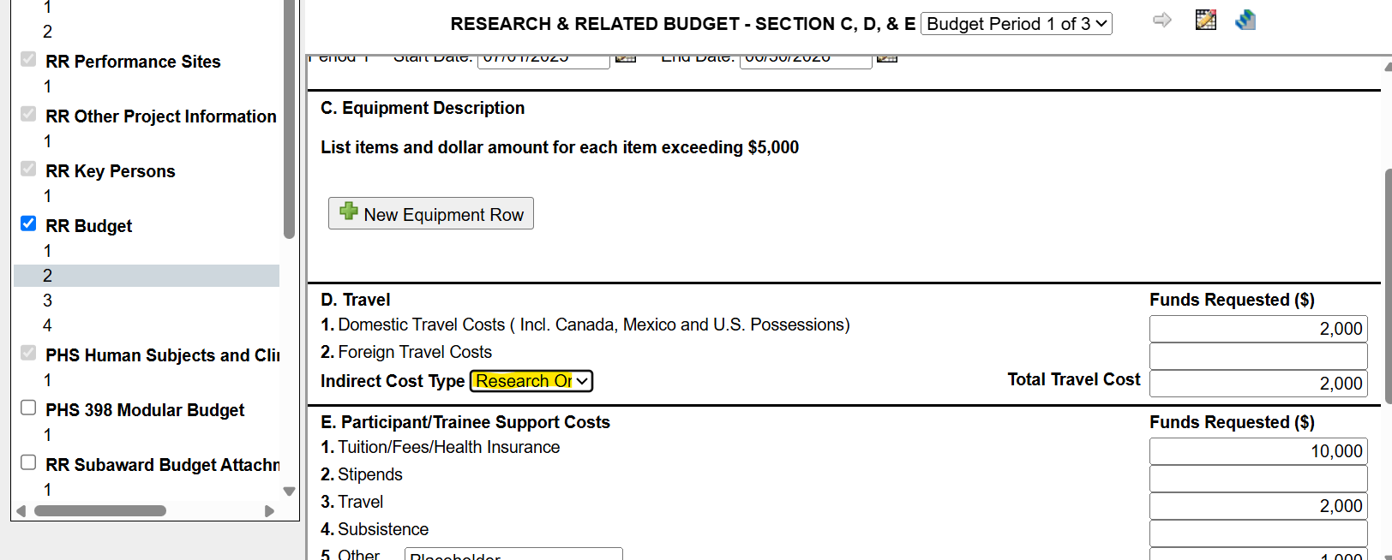

Section F: Other Direct Costs - as applicable
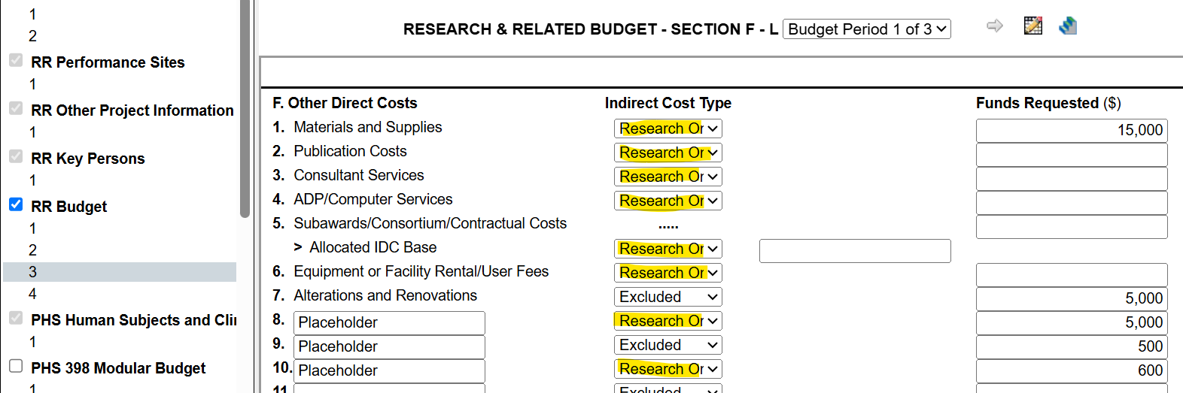

Lastly, if the information in the Cognizant Federal Agency field also gets lost, here is that information:
DHHS, Jeanette Lu, 415-437-7820

